Class & Module | WSQ - Python for Data Science (SF)  Assignment 4 – Create cloud flows for approvals
Name | Gunnam Swaroopa Rani

Assignment 04 entails creating a PowerAutomate flow for approvals.
Scenario
Imagine that you have a list created with Microsoft List in which employees request for devices like monitors or headsets. You want to create an approval process so that every time an employee adds a request to a list, somebody receives a request and approves it.
-------------------------------------------------------------------------------------------------------------------------------
The tasks should be completed using the PowerAutomate license provided by Lithan
Login to the https://www.office.com/ using your Lithan email address
Provide screenshots  as evidences of each completed task for all the tasks:
Pre-Requisites
- Download the EquipmentRequests.xlsx from LMS.
Save it in the Lithan OneDrive.
 > 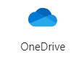
B. PowerAutomate Connectors
The tasks will need to use the following connectors in the flow
Outlook365, Microsoft Teams, Sharepoint so need to check that connections have been authorized.
- Click on the  > PowerAutomateFrom the left bar, click Connections
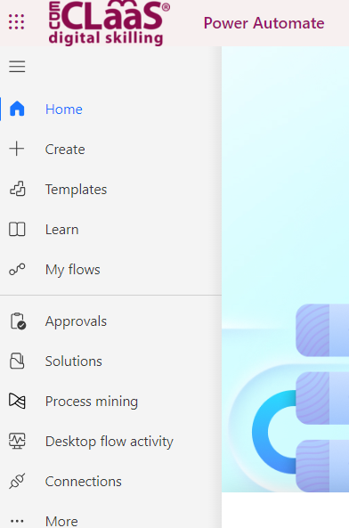
3. Check that the following connections are connected
Search for Microsoft Teams, Sharepoint, Outlook
Example as follows, the status shows as Connected:-
4. If it is not available click on 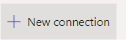, 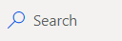 for the connector you need example Outlook.
5. Search for Office 365 Outlook and click on it.
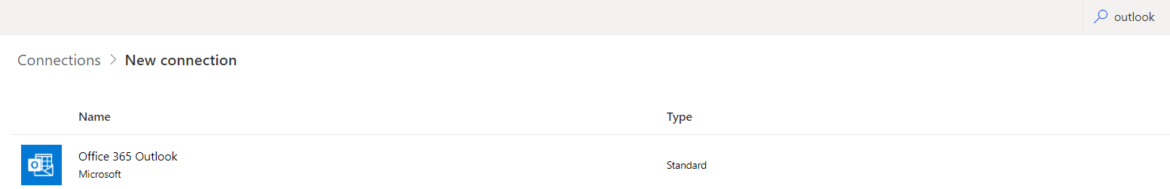
6. Click Create. You will be prompted to sign into your Lithan email id.
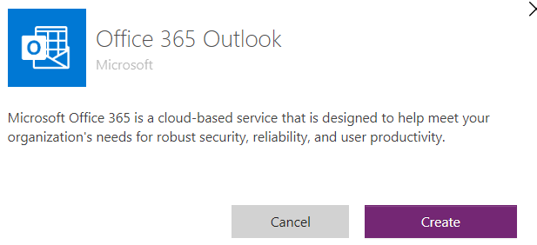
7. Confirm that the connection has been created.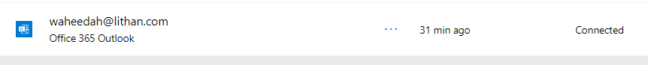
Task 1 : Create a EquipmentRequests list based on an Excel (.xlsx) file
- Click on the  > 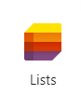.
- Click on 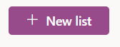
- Select Create a list from Excel
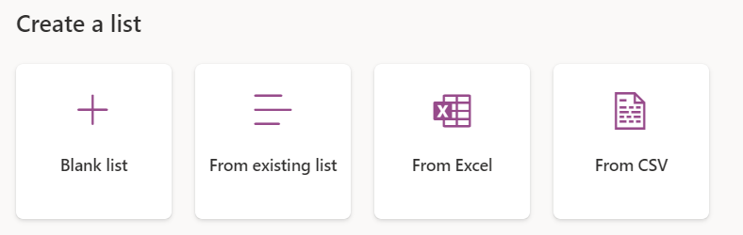
- You can Upload from this device or Choose file from your OneDrive.
Select the EquipmentRequests.xlsx file and click Next.
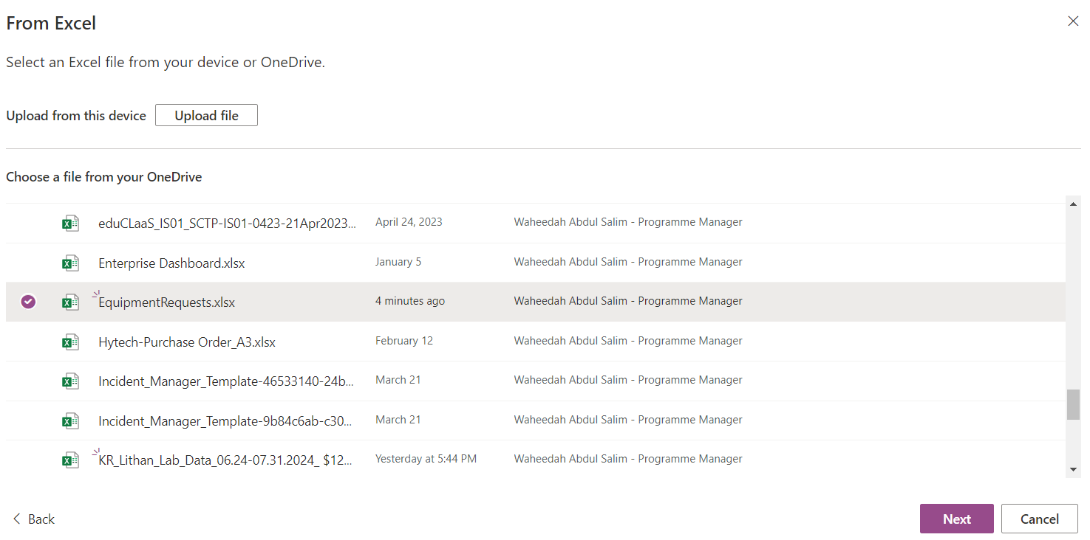
- Click Next.
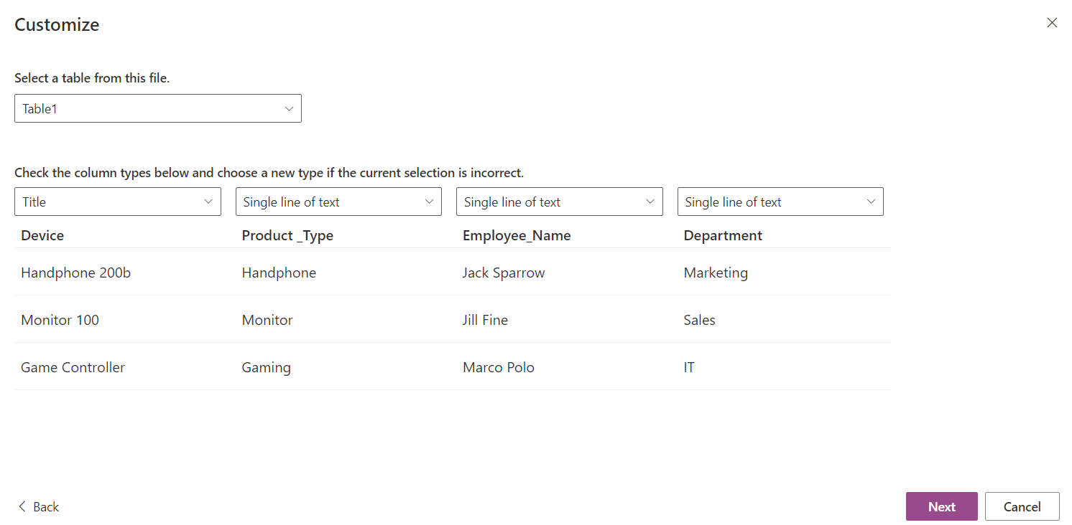
- Enter the description, choose color and icon.
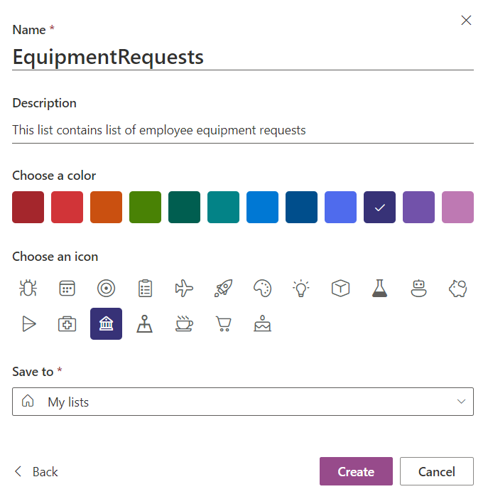
End of Task 1
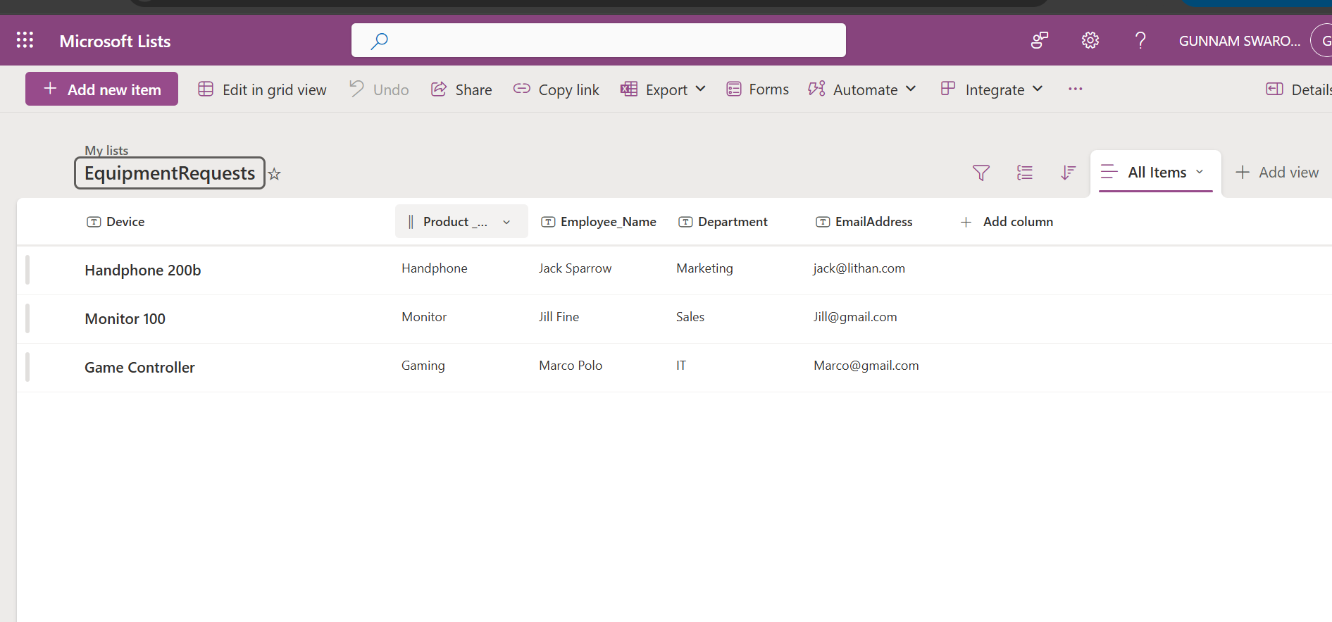
Task 2 : Create a PowerAutomate Flow from a EquipmentRequests List.
The flow will start from a template.
- From the EquipmentRequests List. Click Integrate > PowerAutomate > Create a Flow
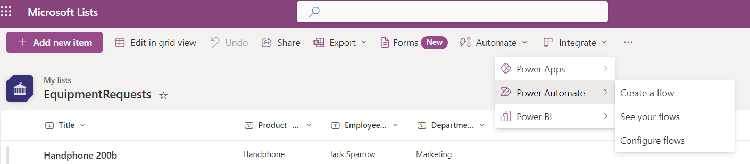
- Choose the PowerAutomate Template below
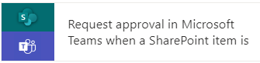
- The flow will use the following connectors
SharepointList., Approvals, MicrosoftTeams
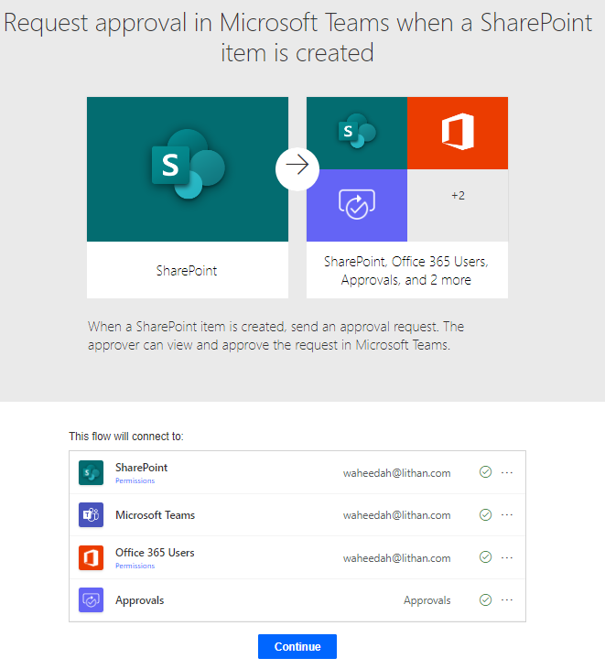
- Ensure that all the connections have a green . Else click on the … and Add a new connection.
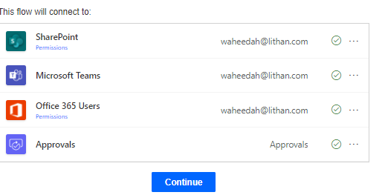
- Click on Continue.
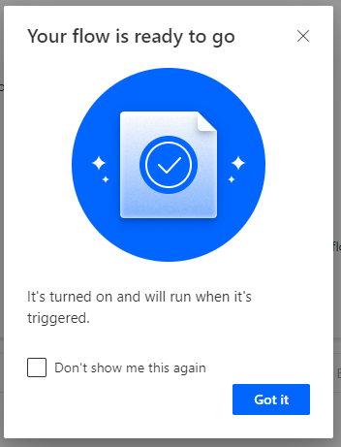

- Edit the Flow
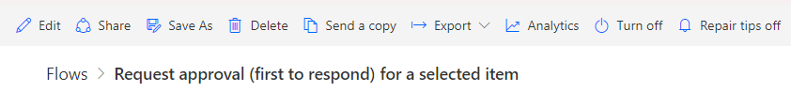

End of Task 2
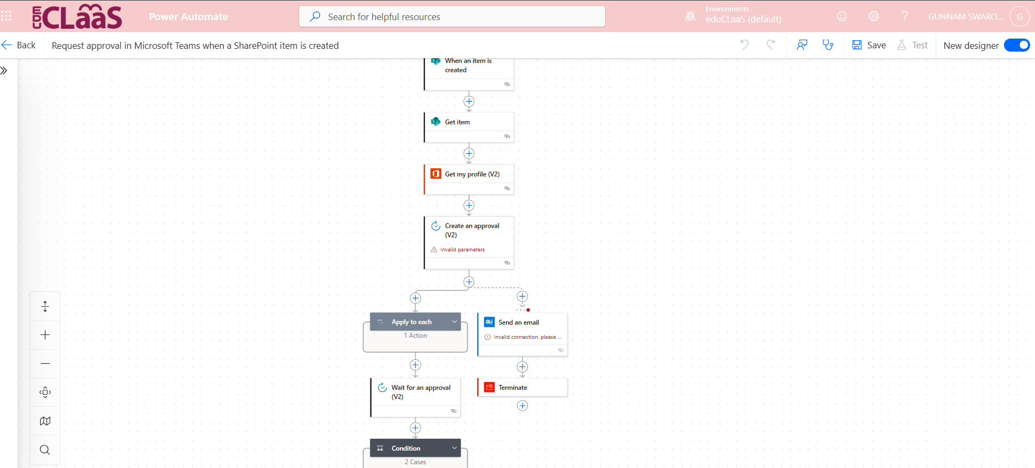

Task 3 : Test the Flow
- Toggle the view from New designer (default) to ClassicView. 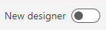
- Delete the dynamic content 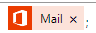 from the listed MSteam and Outlook Connectors below and
Replace it with your Lithan email id in all the above connectors. Refer to below as an example.
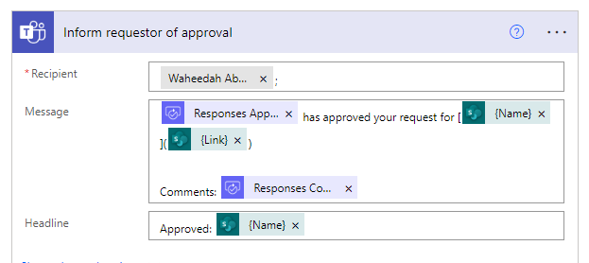
- Delete the connector – Get my profile. Click on … to Delete.
This connector will only work if the requestor is found in the EntraID.
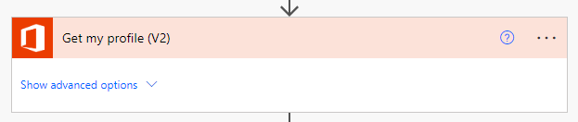

- For the Create an approval connector, make the following changes.
Title : Request for new (Device - dynamic content) for (Employee_Name - dynamic content)
Assigned to : Use your Lithan email id
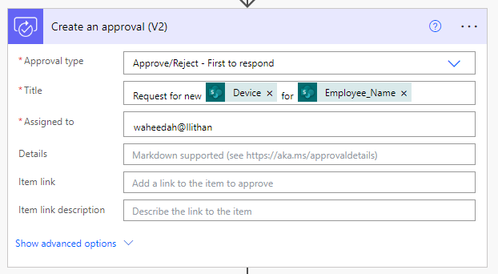
- Click 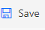
- If an error is received, then check all connectors to ensure its connected.
*Hint – Check the Send an email connector
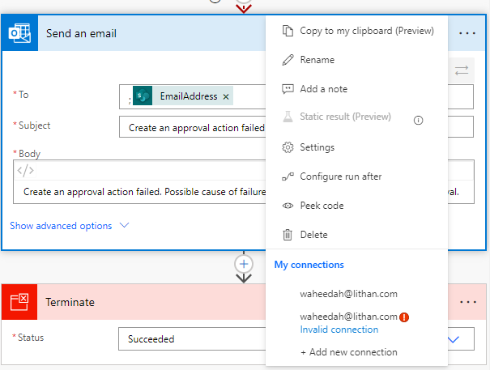

- Click on one of the connection to authorize it (tick) or +Add new connection if there is no connection.
Connections can also be created following the steps from B. PowerAutomate Connectors(Pre-Requisite).
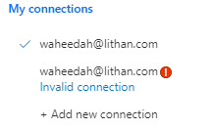
- Click 
- Click 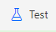
- Click Manually to Test the Flow.
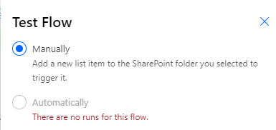
Note: This message indicates that to TRIGGER the flow to start, a new item needs to be added into the EquipmentRequest Sharepoint List.
- In the EquipmentRequests Sharepoint List, 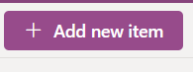.
Input Test Data and Save.
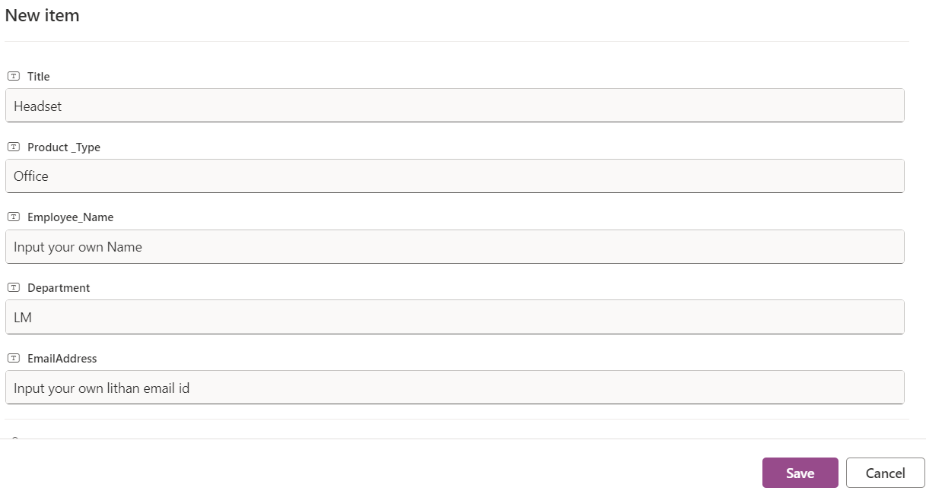
- The flow will show as 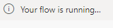 and the workflows will prompt you to approve via MS Teams.
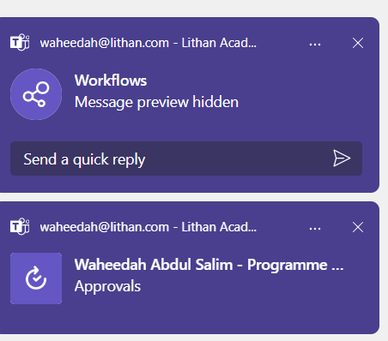
- The flow will wait for approval until you reject or approve the request.
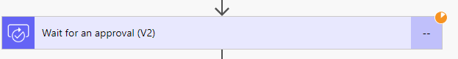

- Click on MSTeams >Approvals.
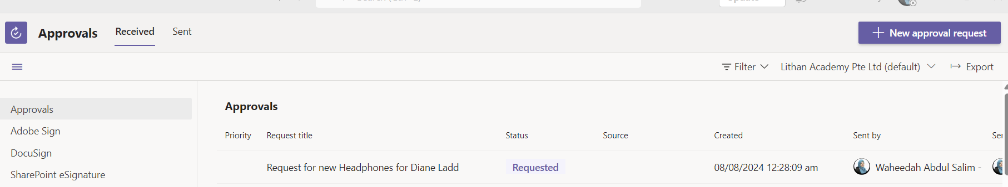

- Approve the request
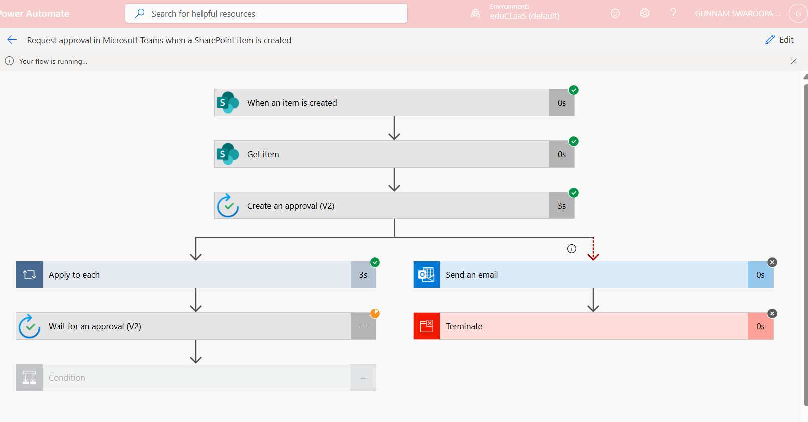

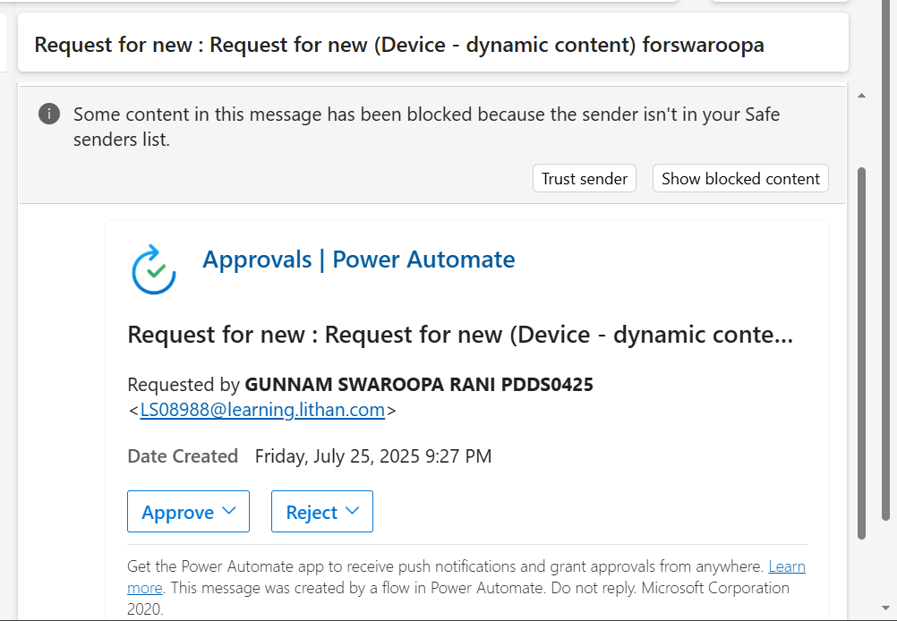
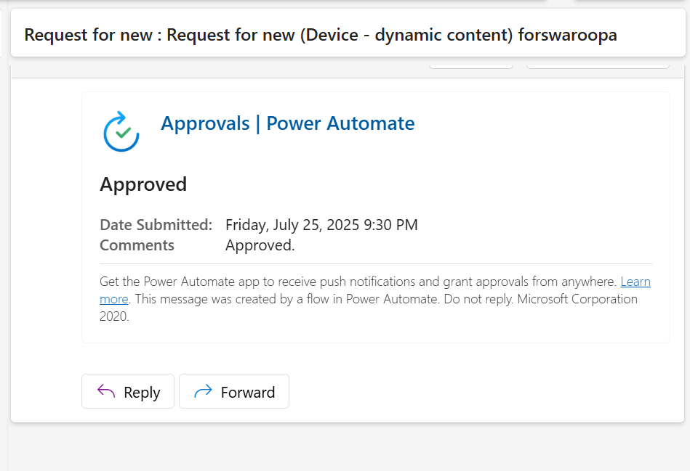
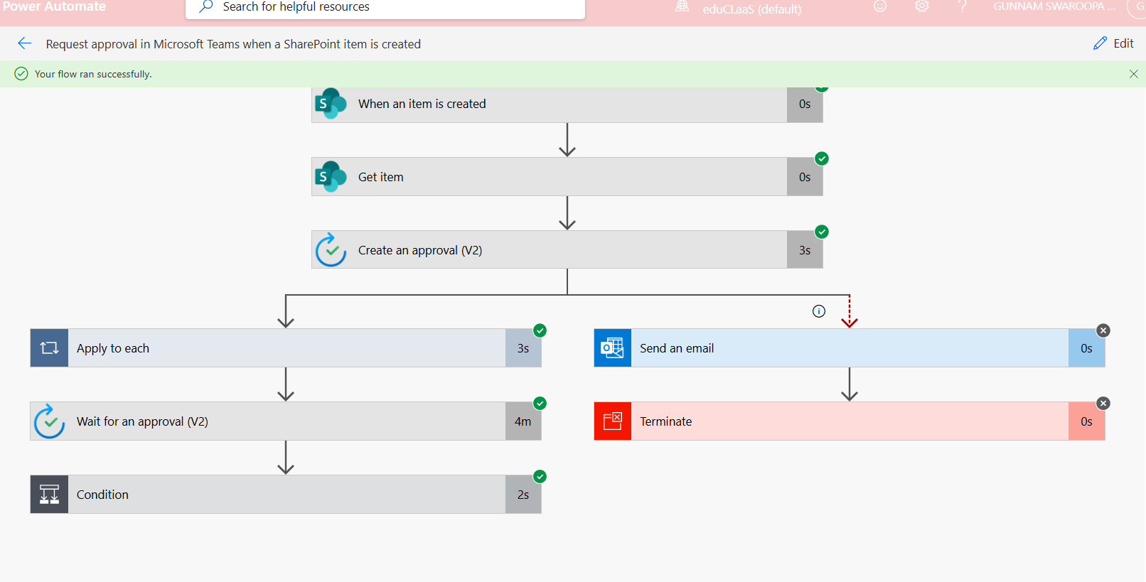

- Create another new entry into the Microsoft List and reject the request.
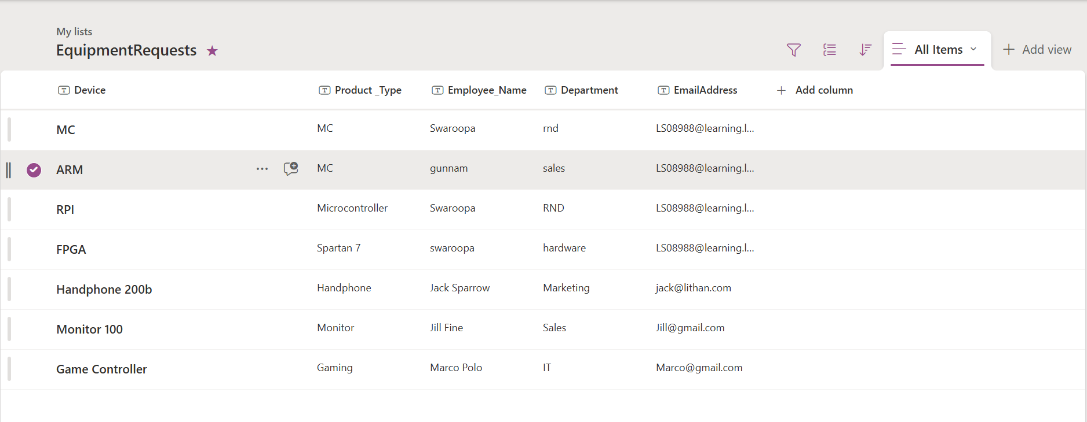
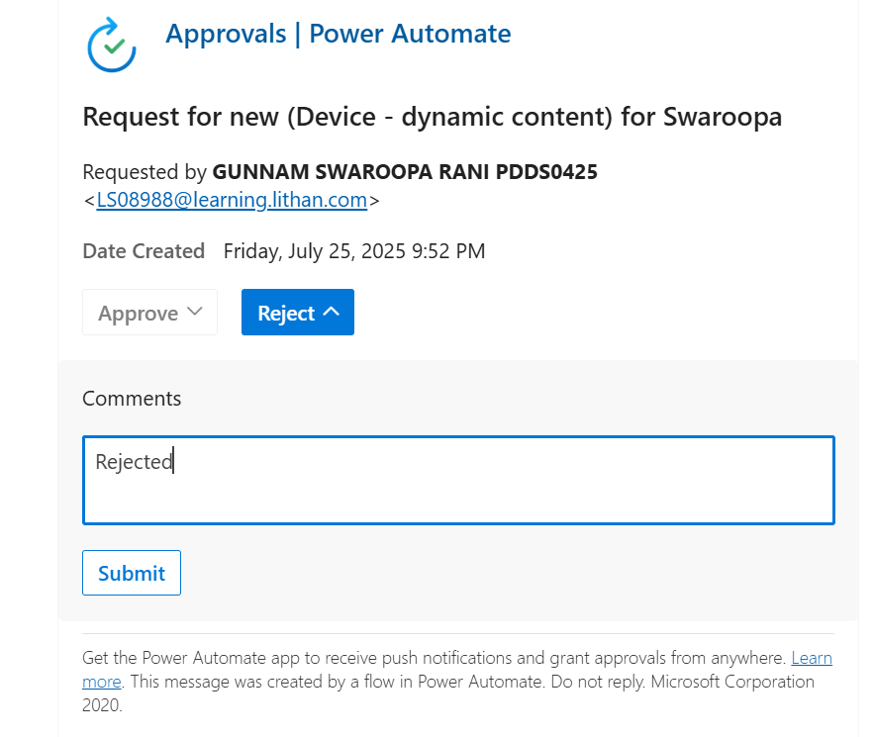
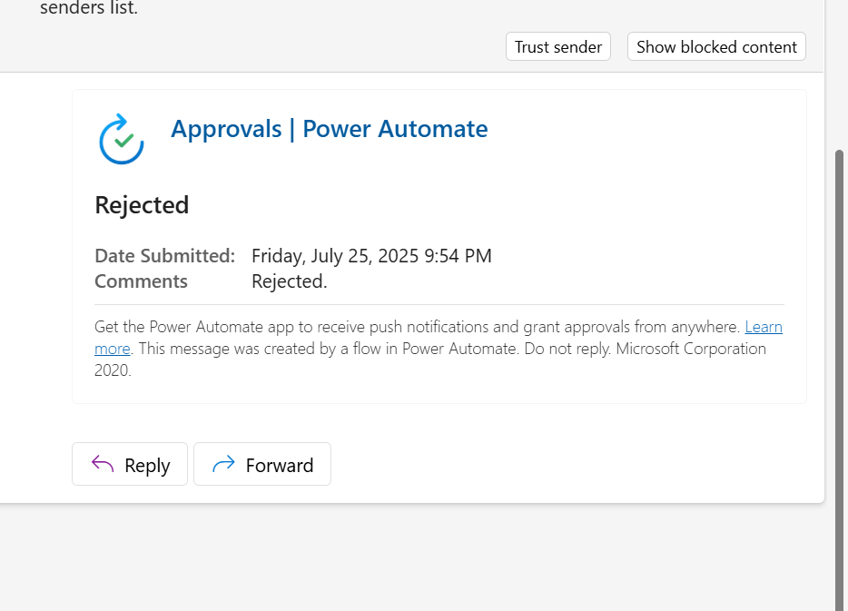

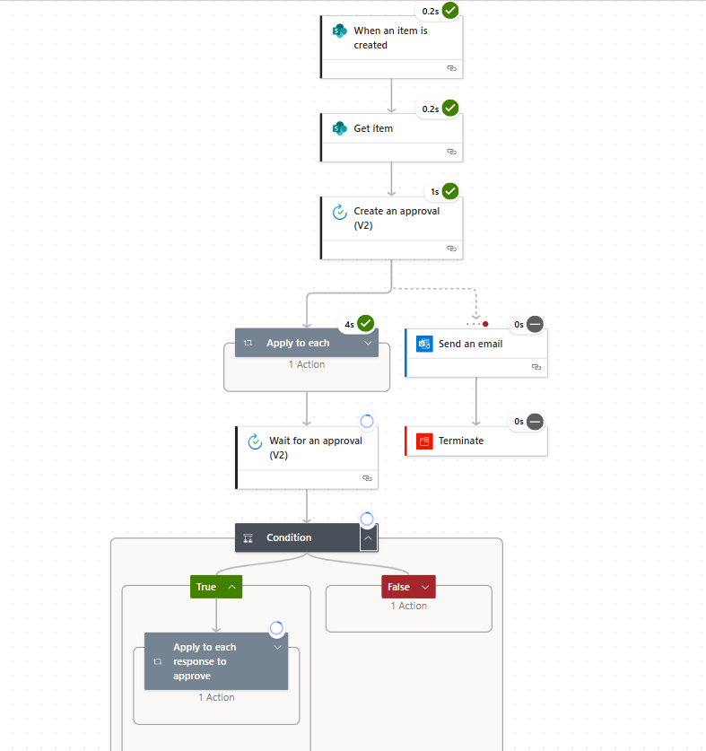
End of Task 3

Task 4 : Dynamic Content
- What is dynamic content?
Dynamic content in Power Automate refers to the variables, fields, or data values that are automatically pulled from previous steps in your flow and can be used in later steps.
- From the tasks listed above, provide an example of dynamic content.
While performing above tasks execution dynamic content examples are like Name, Link, EmailAddress, Employee_Name..
- In this step, for Recipient you have used your own Lithan email id, 
What adjustments can you implement to ensure that the recipient of the MS Teams message is consistently the requestor?
Tip: Consider the dynamic content options available for SharePoint lists.
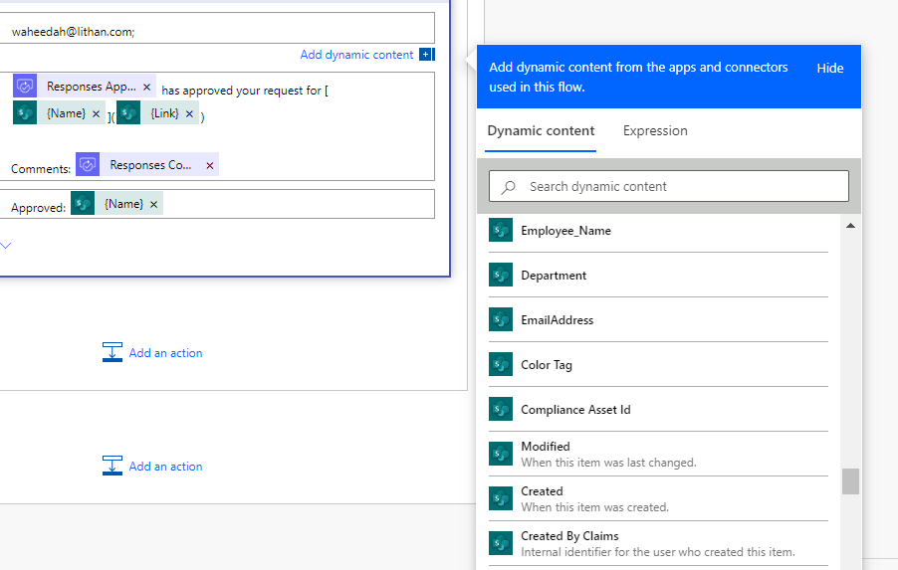
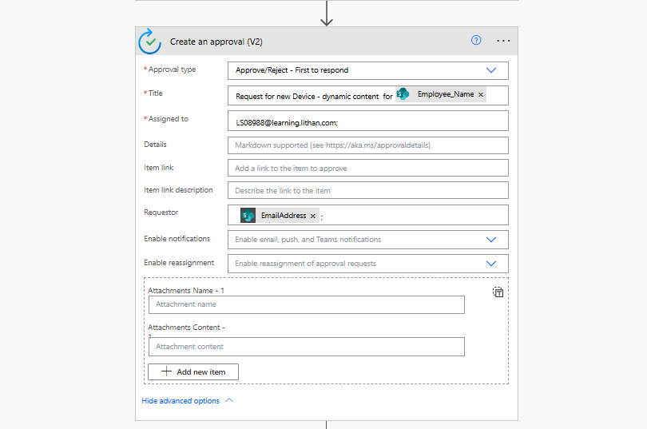
- Make changes to the flow and Test it.
Add a new item into the EquipmentRequests Sharepoint list.
The email address you have input into the EquipmentRequests Sharepoint list needs to be a valid email id else the flow will fail.
Note: You can input your own email id in the list.
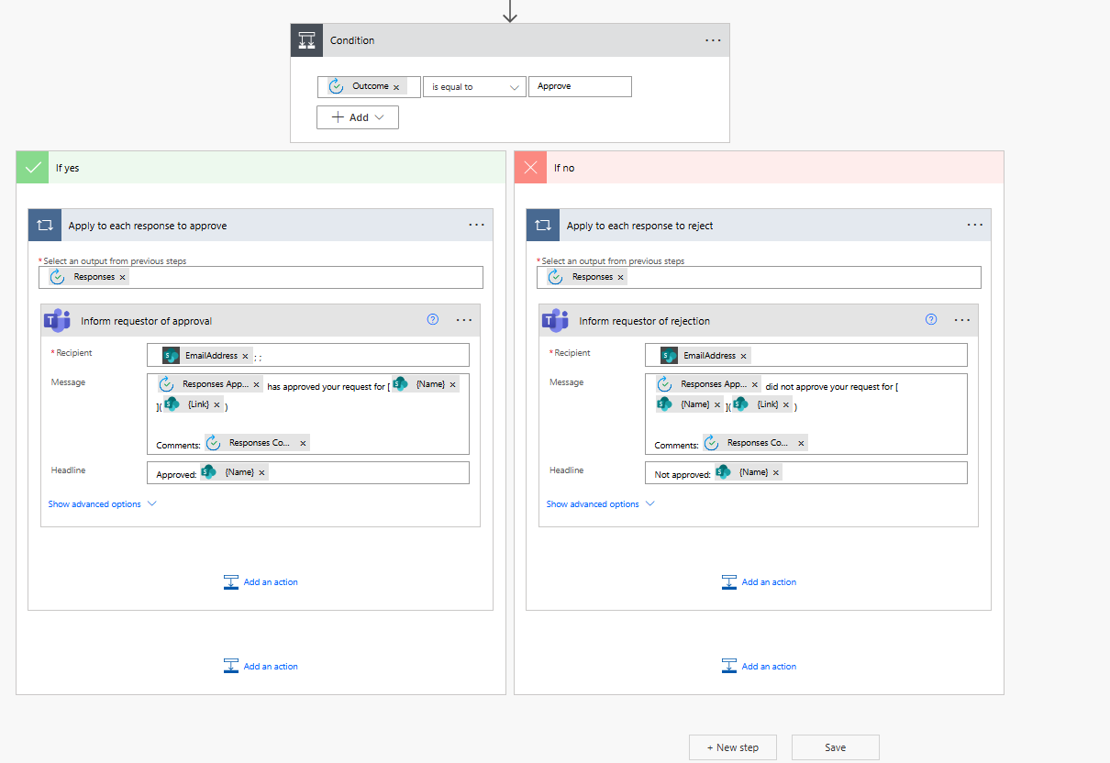
- Approve the request
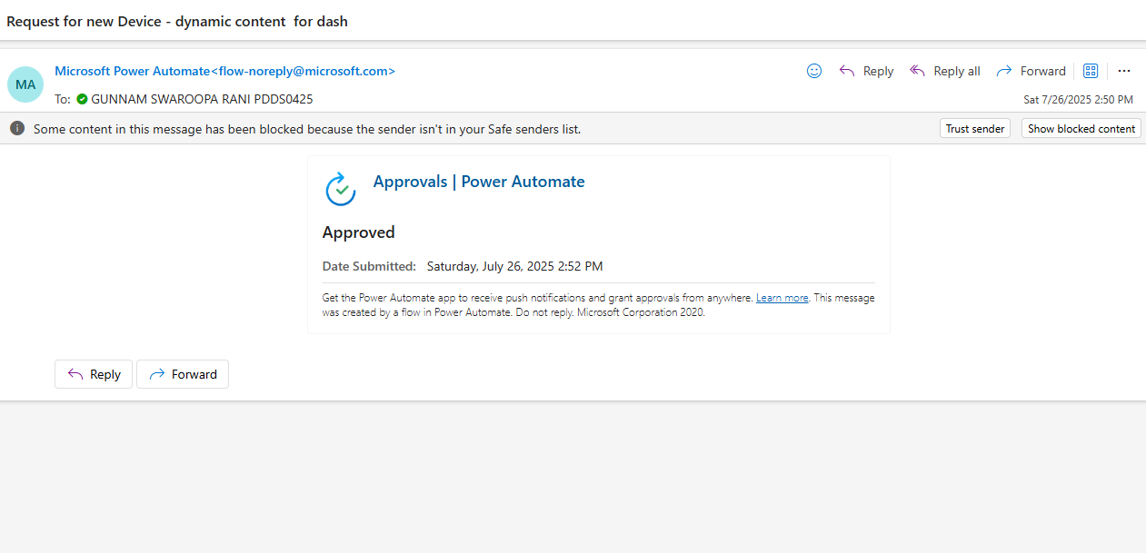
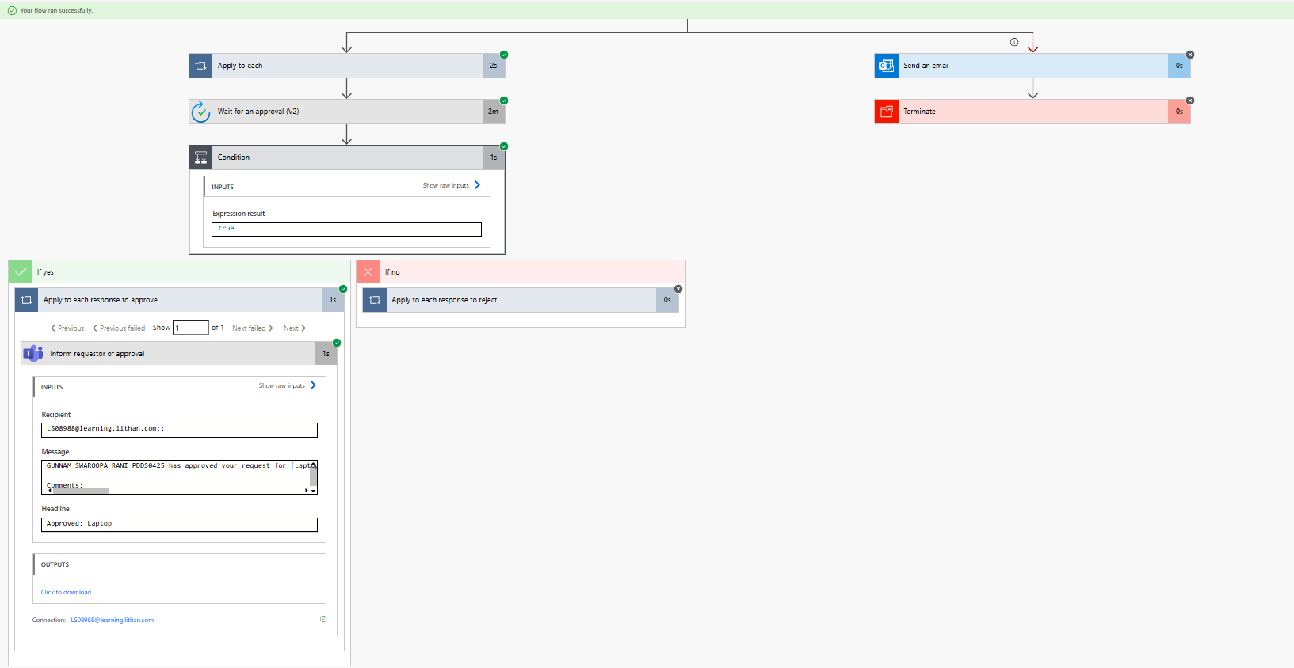
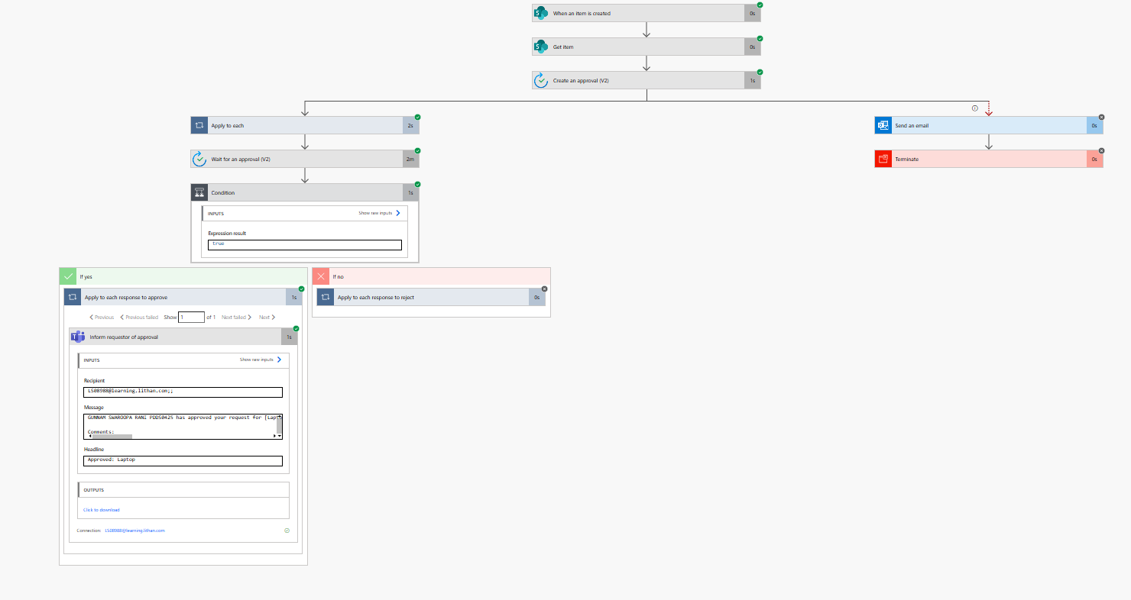
End of Task 4 and Assignment 04

